# Mongo DB Installation Guide

Guide for downloading and installation of MongoDB on Windows

## Downloading the MongoDB MSI Installer

Download the current version of MongoDB from [here](https://www.mongodb.com/try/download/community). Make sure you **select MSI** as the package you want to download:

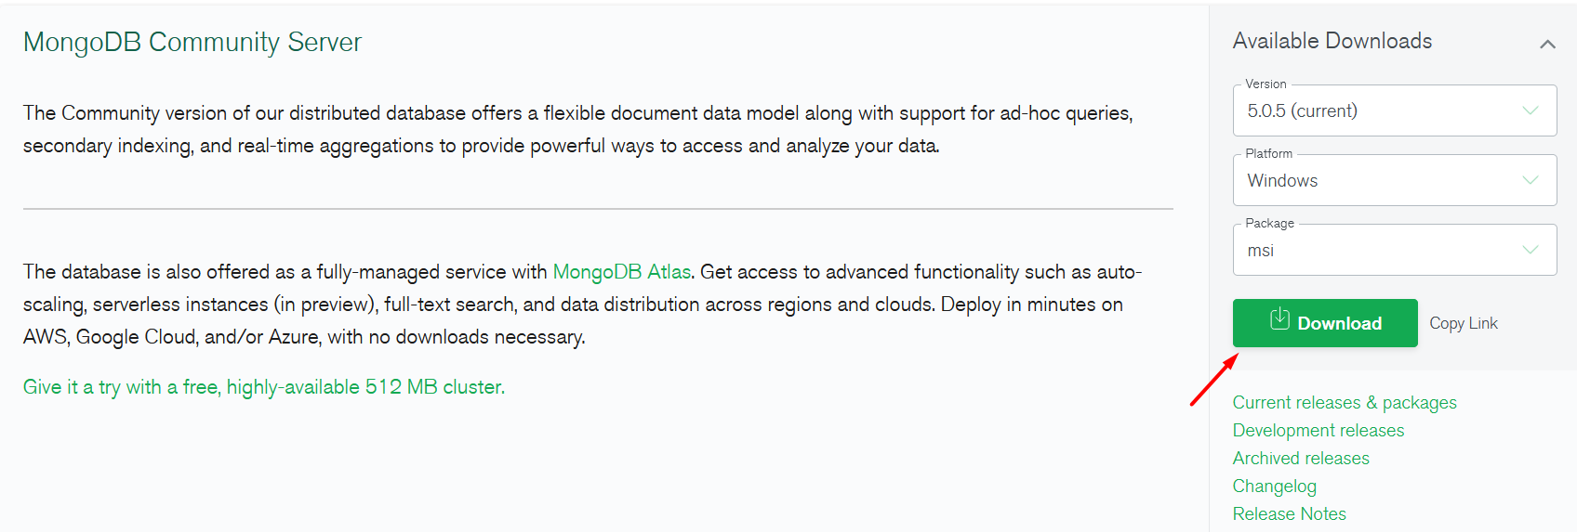

## Installing MongoDB 5.0.5

Navigate to your downloads folder and double click on the **.msi** package you just downloaded. This will launch the installation wizard.

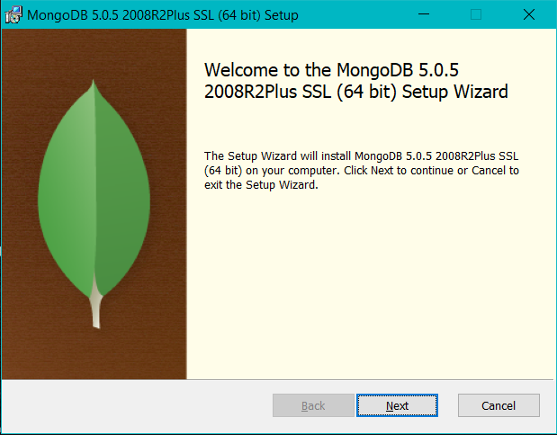

Click **Next**, then accept the license agreement and click **Next** again. Choose the **Complete** setup type:

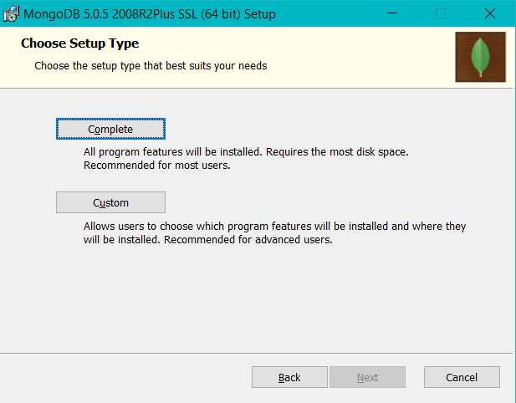

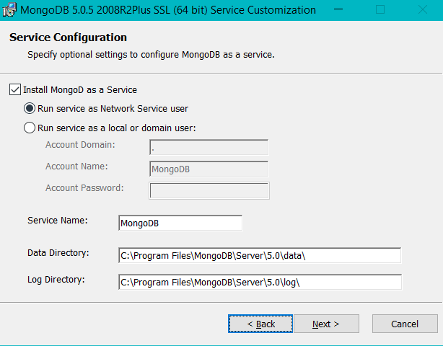

Here we stay with the default option **Install MongoDB as a Service** and **Run service as Network Service user**.

Then go through **Install** and **Finish** like this:

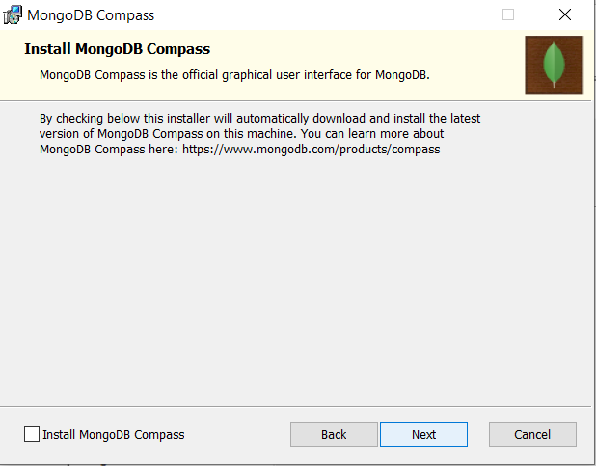 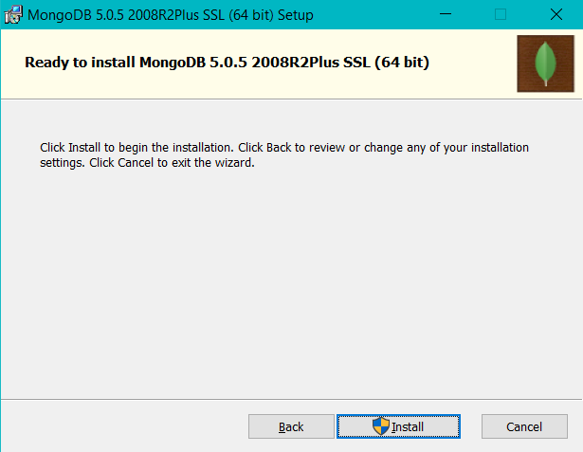

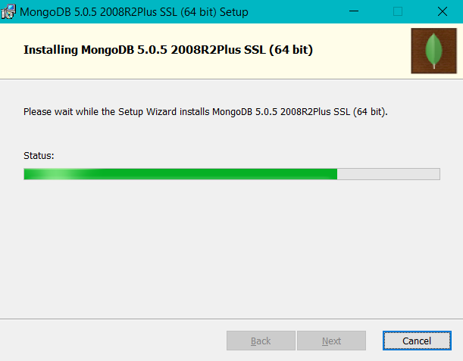 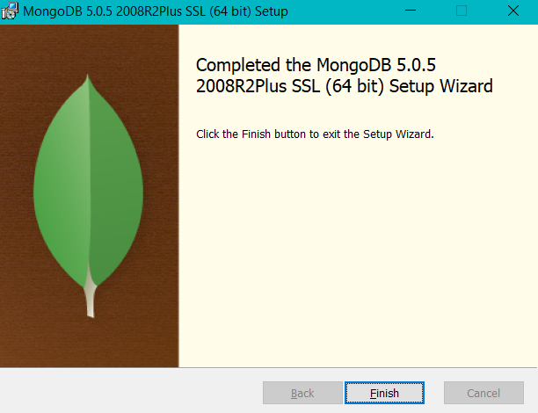

After finishing the installation you need to **restart** your system.

## Testing the Console Client

Navigate to the installed MongoDB **bin** folder.

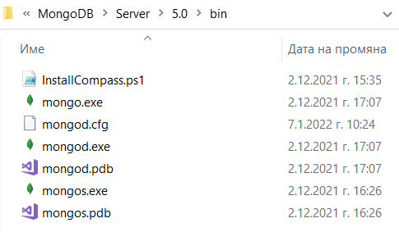

Open the folder in command prompt and run **>mongo** command.

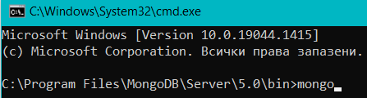

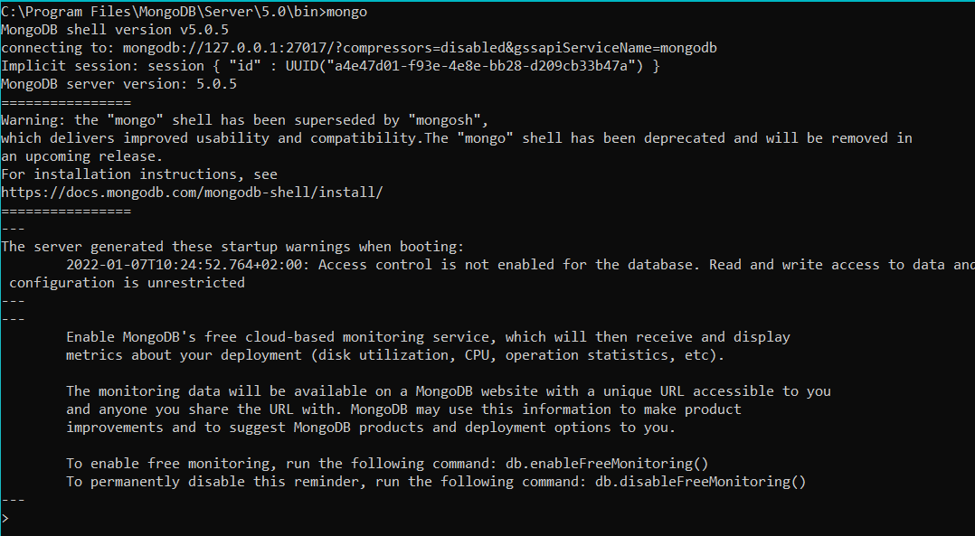

This will run the **MongoDB shell**. You can use the mongo shell to query and update data as well as perform administrative operations. Here we can test and manually create a new database, add a collection to it.

To print a list of all databases on the server we use the **>show dbs** command.

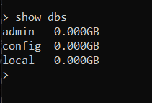

Creat new database by **> use <databaseName>**

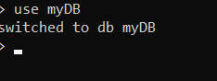

To see the new database with the show command we should first put the same data in it. We can create a new collection with a document using **> db.<collectionName>.insert(document)** . Example:



Now **> show dbs** will show us our new database:

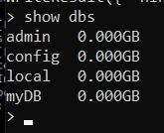

And **> show collections** will show us the new collection:

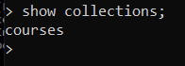

Executing **> db.collection.find()** in the mongo shell automatically iterates the cursor to display up to the first 20 documents if any.

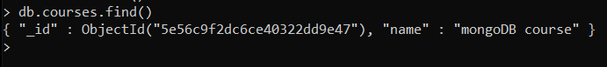

Now you have MongoDB installed, tested, and ready to work. More info read on [**The MongoDB 4.2 Manual.**](https://docs.mongodb.com/manual/mongo/)

## Installing MongoDB Compass

**MongoDB Compass** is a client GUI tool designed to manage and interact with MongoDB databases. It provides a user-friendly interface that allows developers and database administrators to visualize, explore, and manipulate data in MongoDB.

Download MongoDB Compass: <https://www.mongodb.com/try/download/compass>

Install it on your laptop:

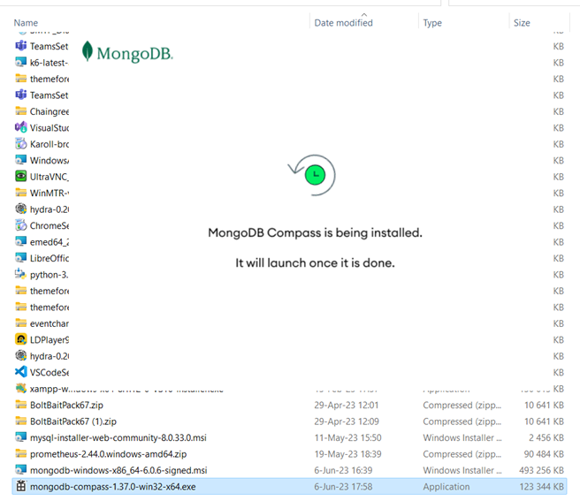

## Playing with MongoDB Compass

Launch MongoDB Compass, after the installation and connect to the MongoDB database server.

Create a **database** “**blog**” and a **collection** “**article”** inside it and insert a **few objects** in it:

Sample JSON data. This is a sample data row:

|  |
| --- |
| {  "title": "AutoGPT",  "readTimes": 31,  "body": "AutoGPT is a tool to automate ChatGPT with Internet searches for solving more complex tasks"  } |

Another data row:

|  |
| --- |
| {  "title": "Playground AI",  "readTimes": 112,  "body": "Playground AI is an image generator based on stable diffusion"  } |